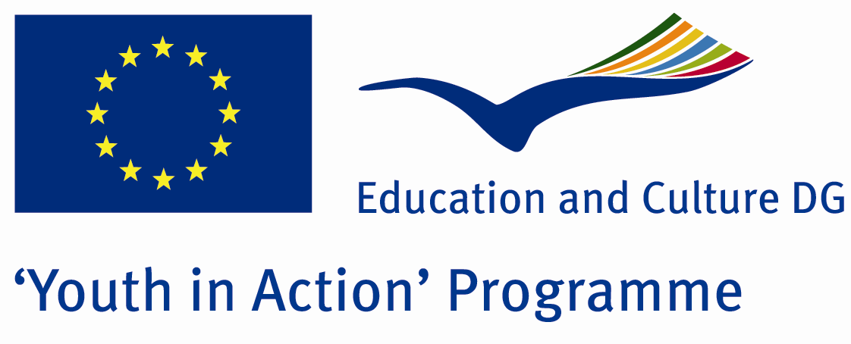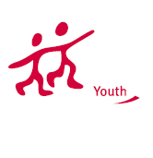

Man and Women



ACTION 4.3 – Training And Networking

24-29th October 2011

Sakarya/TURKEY

Please contact directly to;

adventurerpeacepigeons@gmail.com

Project Summary;
In this Project, we aim to attract attention the equality or non equality of man and woman…
In all over the world, for old times, the women have been in second plan… Because in old times, everything depended on phsical strength..and because of man creativity, the men were stronger than woman.But anymore, in our day, eveything depends on mind, Money, education and the other things…despite of this, the women couldnt reach the men’s situation. But if we are living in a equal world, if our sexes are not our choice, if in this world we are living, working, dieing, eating together and if all the problems and all the good events ar efor all of us, then we must be equal..Dont forget, every man borns from a woman..so, they are as important as a man …it must be….With this opinion and aim, we want t maket his Project….I hope you will join us….please for cntact use information in info packs.

Project Title; Man and Woman

Date and Venue; 20-29th October 2011 Sakarya/TURKEY

Target Group; Non profit/non governmental organization, Public body, Body active at European level in the field of youth (ENGO), Informal group of young people, e.t.c…

Participants; 5 people from each country (18 - 25). Totally 8 countries.

Conditions; Accommodation, board and programme costs will be financed through European Commission Youth in Action Programme (Action 4.3). Travel costs will be reimbursed in 70% (APEX Tarrifs). Organizations from all 27 EU member countries plus Liechtenstein , Norway and Iceland are eligible to take part.

Working language: English

Organizer; Discovery And Adventure Group

How to apply: If you are interested, please send your Part III forms to
by e-mail please (in word file). Scan Part3 format is enough for application.(Fulfilled Part III which you can find in the attachment, of course signed and stamped) ..

Next step 2;
Original send via regular post to this address please:
Ertan DERİN
Fevzi Çakmak Mahallesi Tuncer Sokak No:6 PENDİK/İSTANBUL/TÜRKİYE
e-mail : adventurerpeacepigeons@gmail.com
Mobile : 0090 542 393 93 90

If you have any questions you may contact with: adventurerpeacepigeons@gmail.com
Deadline: 15th May 2011

For Further information:
Contact Person
Ertan DERİN
Fevzi Çakmak Mahallesi Tuncer Sokak No:6 PENDİK/İSTANBUL/TÜRKİYE
e-mail : adventurerpeacepigeons@gmail.com
Mobile : 0090 542 393 93 90

